AI Assisted Coding
Name: U.V.S CHETHAN
Roll no:2503A51273
Assignment no:16

Task 1 – Employee Management Database
Task : Create relational tables with keys/constraints and write the required JOIN, aggregate, and analysis queries.

SQL Code
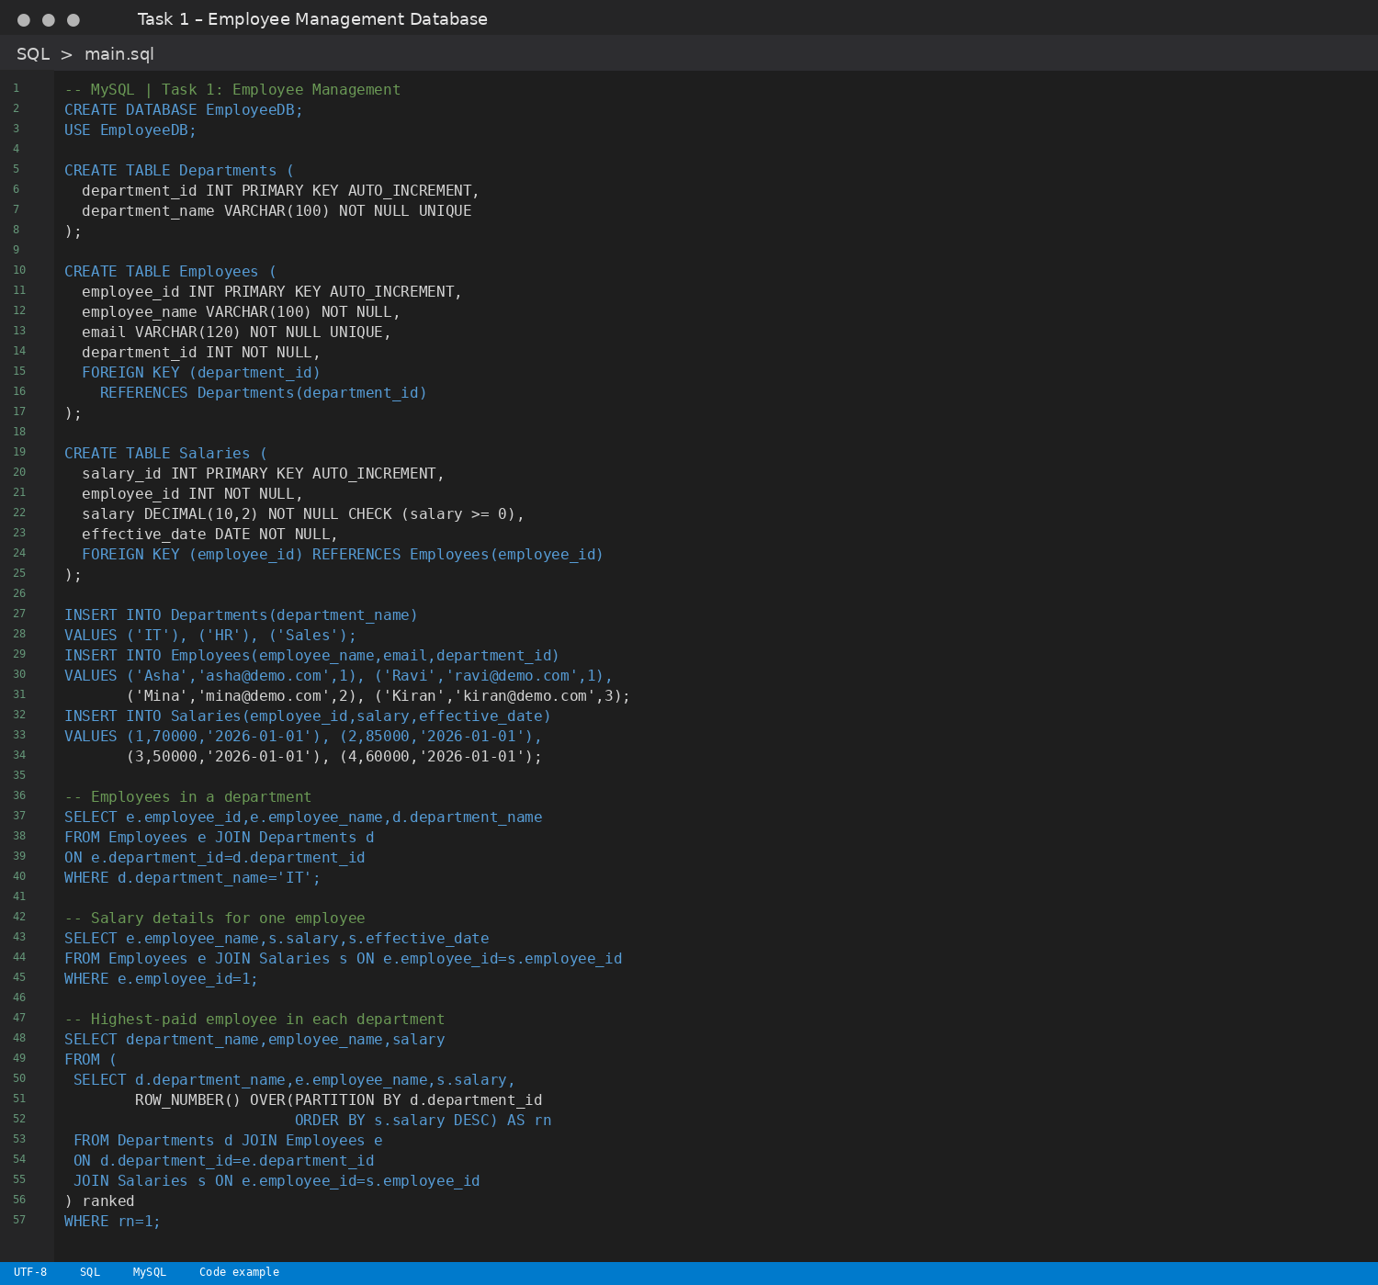

Expected Output
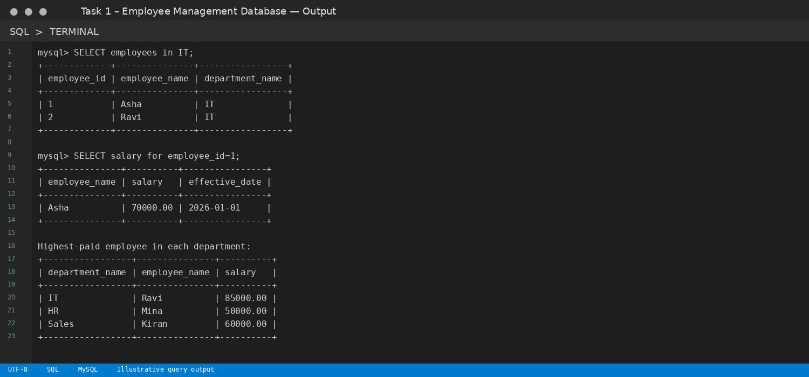
Note: For the airline task, available seats are calculated from booked tickets. For the hotel task, room availability uses overlapping date ranges, and occupancy is calculated for the selected date.

Task 2 – Online Course Platform Database
Task : Create relational tables with keys/constraints and write the required JOIN, aggregate, and analysis queries.

SQL Code
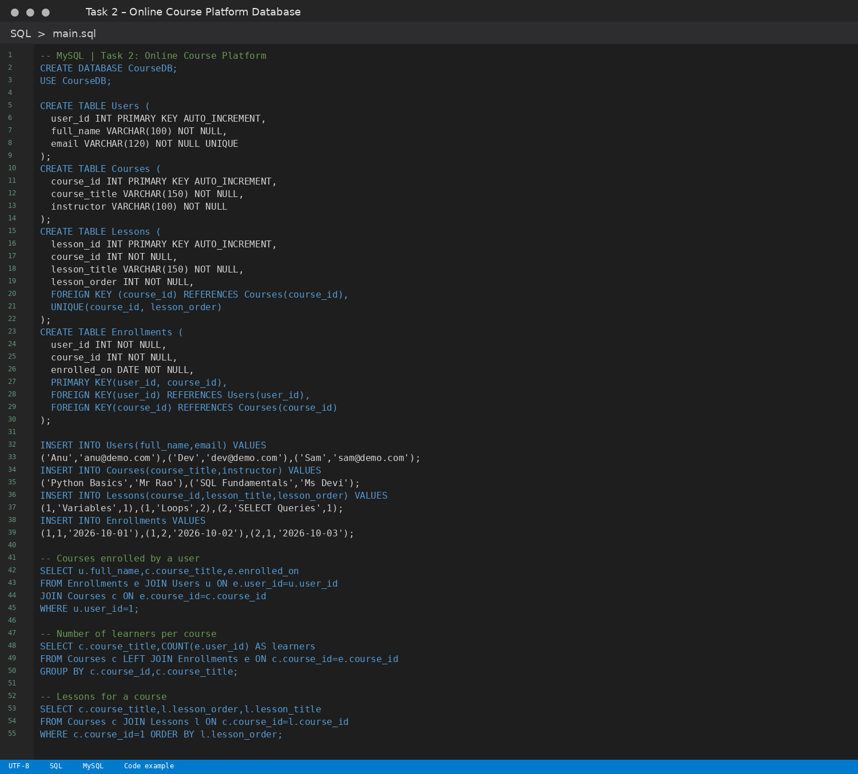

Expected Output
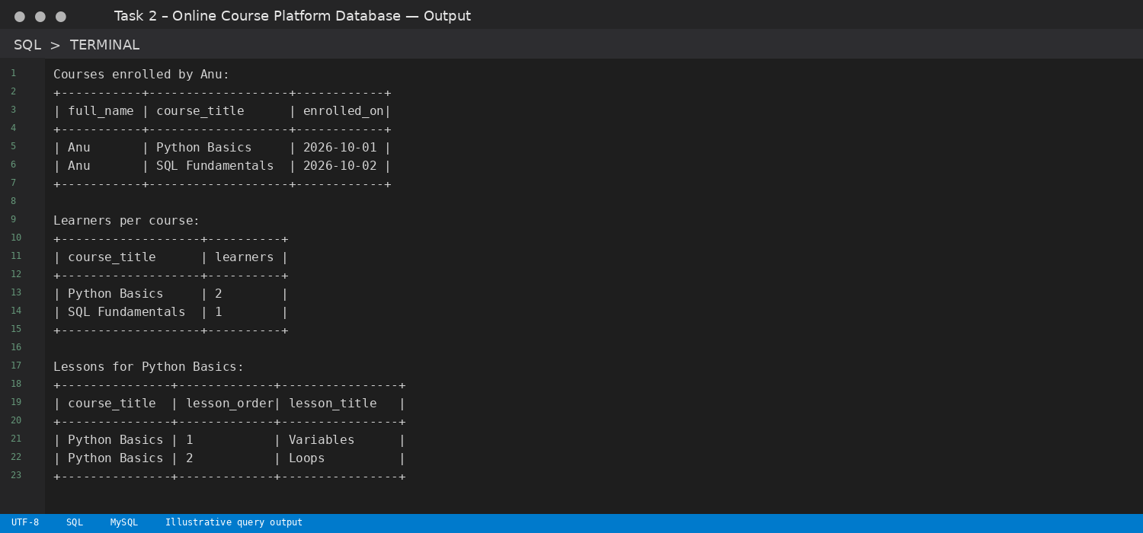
Note: For the airline task, available seats are calculated from booked tickets. For the hotel task, room availability uses overlapping date ranges, and occupancy is calculated for the selected date.

Task 3 – Banking Transaction Database
Task : Create relational tables with keys/constraints and write the required JOIN, aggregate, and analysis queries.

SQL Code
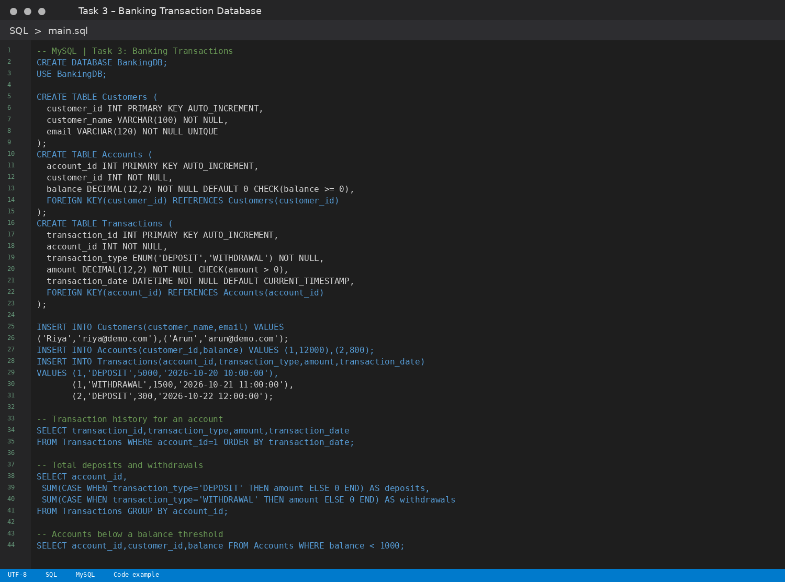

Expected Output
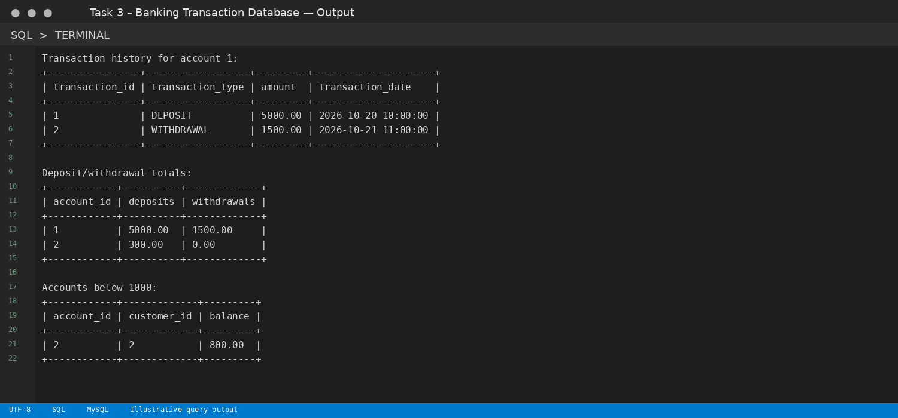
Note: For the airline task, available seats are calculated from booked tickets. For the hotel task, room availability uses overlapping date ranges, and occupancy is calculated for the selected date.

Task 4 – Airline Reservation Database
Task : Create relational tables with keys/constraints and write the required JOIN, aggregate, and analysis queries.

SQL Code
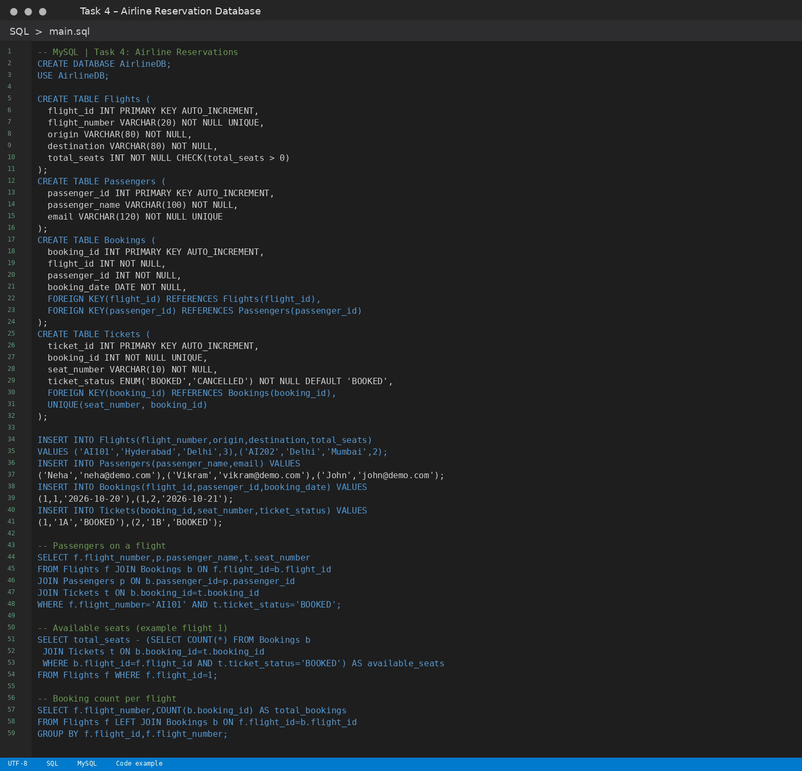

Expected Output
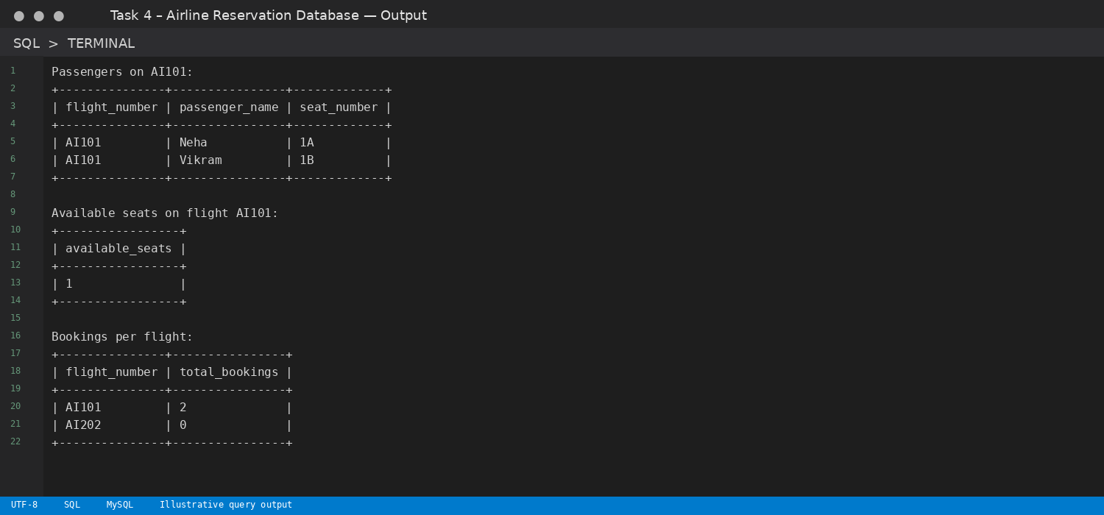
Note: For the airline task, available seats are calculated from booked tickets. For the hotel task, room availability uses overlapping date ranges, and occupancy is calculated for the selected date.

Task 5 – Transport Management Database
Task : Create relational tables with keys/constraints and write the required JOIN, aggregate, and analysis queries.

SQL Code
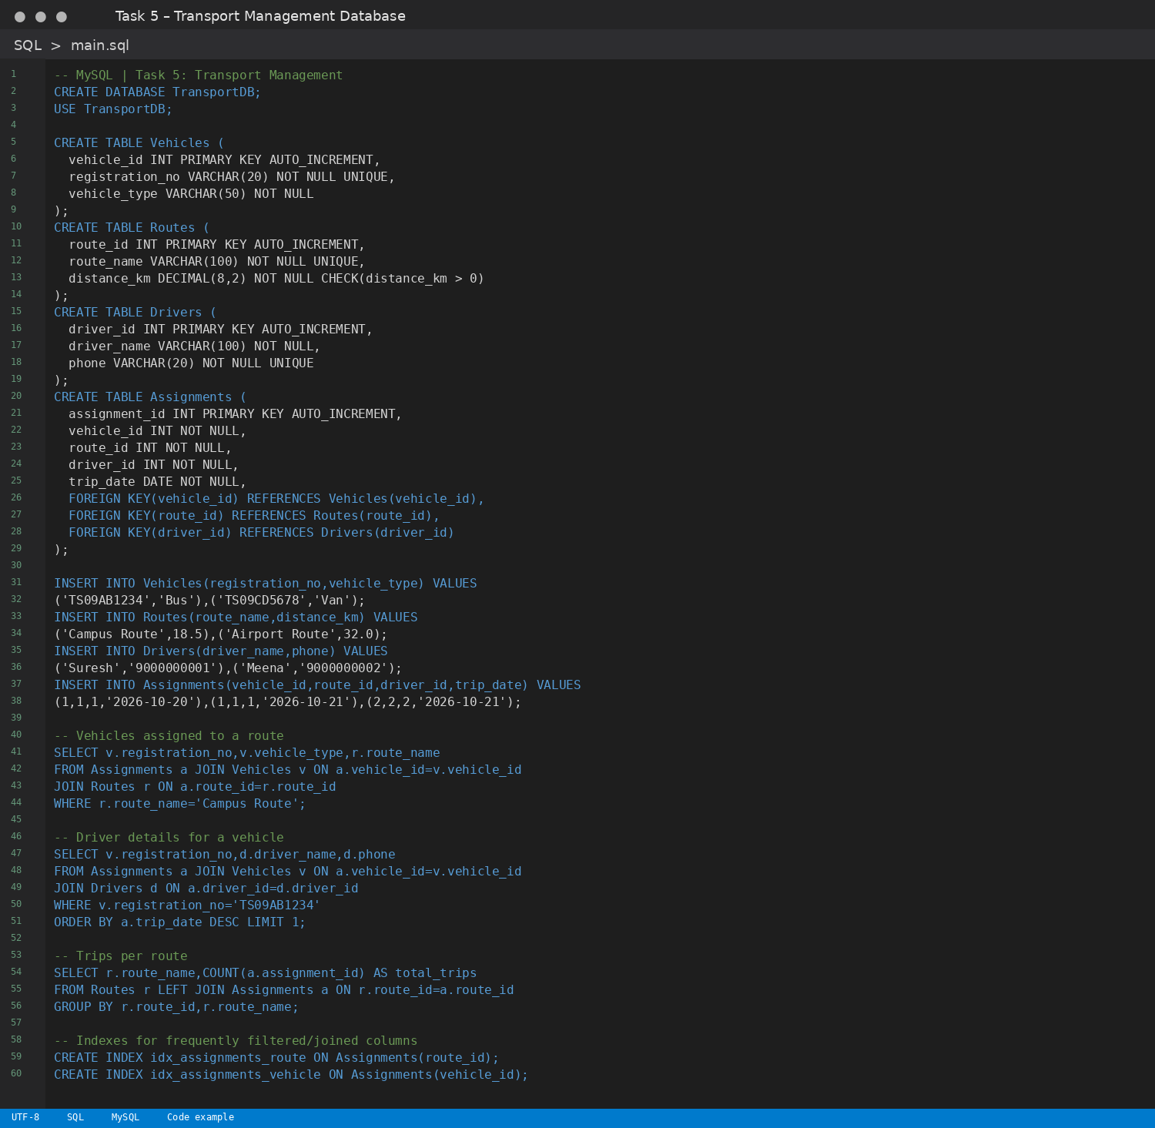

Expected Output
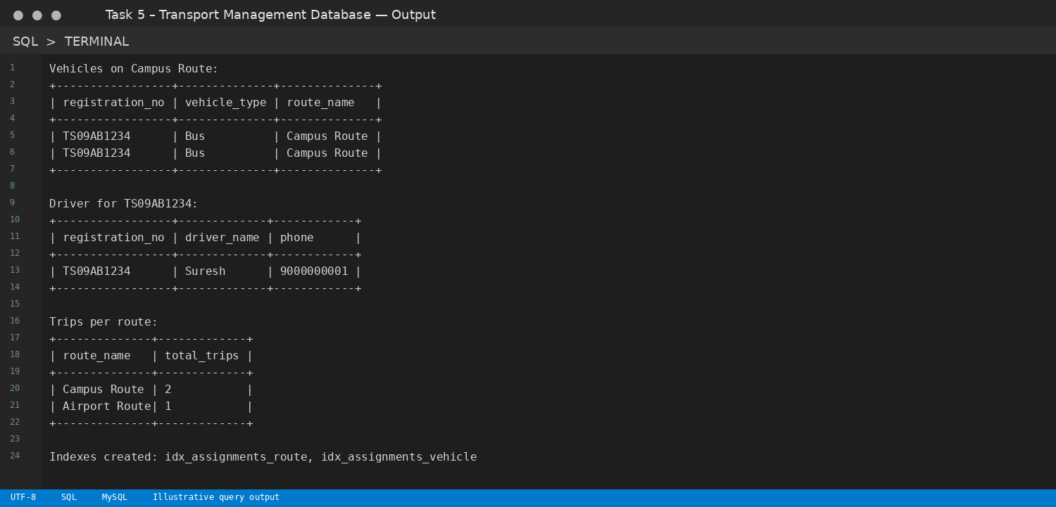
Note: For the airline task, available seats are calculated from booked tickets. For the hotel task, room availability uses overlapping date ranges, and occupancy is calculated for the selected date.

Task 6 – Hotel Reservation Database
Task : Create relational tables with keys/constraints and write the required JOIN, aggregate, and analysis queries.

SQL Code
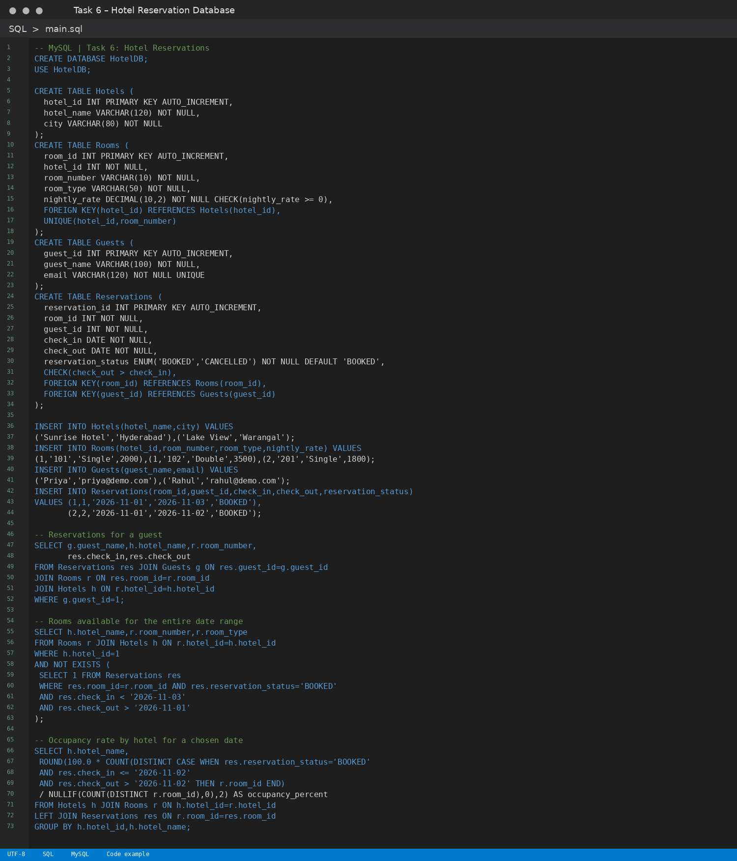

Expected Output
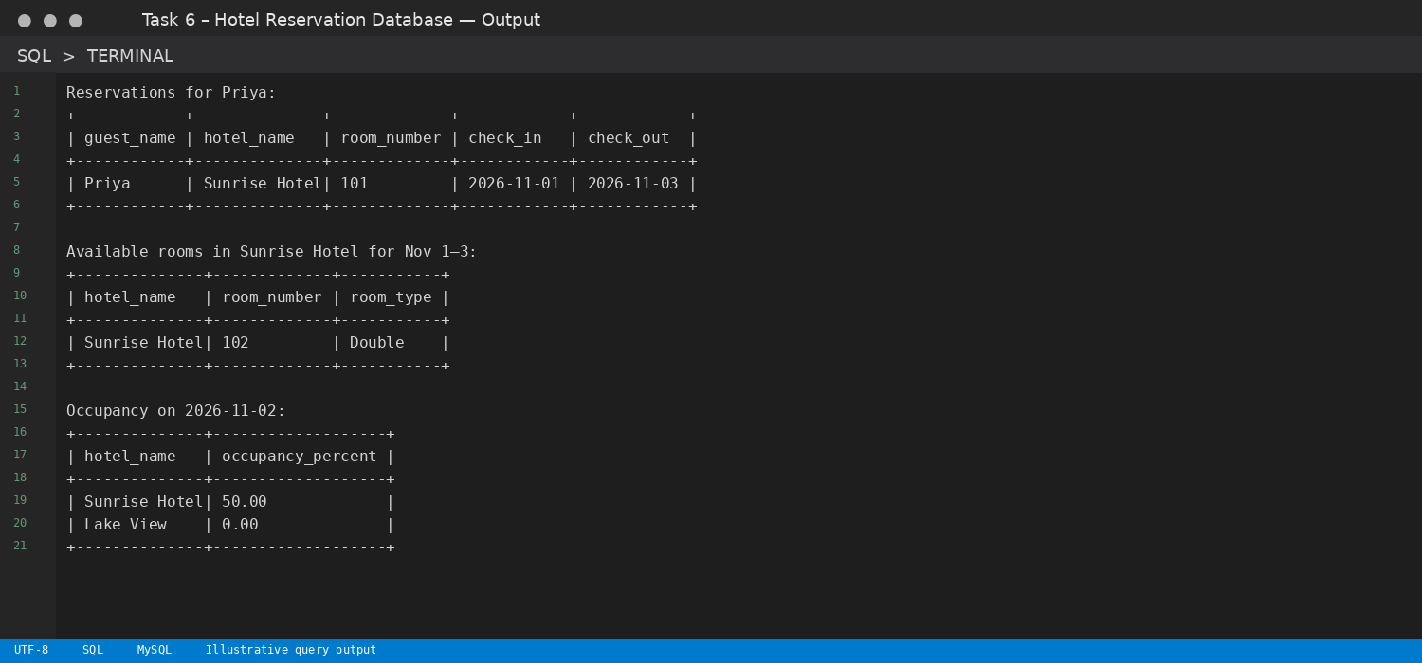
Note: For the airline task, available seats are calculated from booked tickets. For the hotel task, room availability uses overlapping date ranges, and occupancy is calculated for the selected date.

